**DAILY ONLINE ACTIVITIES SUMMARY**

|  |  |  |  |  |  |  |  |
| --- | --- | --- | --- | --- | --- | --- | --- |
| **Date:** | **20/06/2020** | | | | **Name:** | **Churashma** | |
| **Sem & Sec** | **4th SEM 'A' Section** | | | | **USN:** | **4AL18CS019** | |
| **Online Test Summary** | | | | | | | |
| **Subject** | | **Data communication** | | | | | |
| **Max. Marks** | | **30** | | **Score** | | **26** | |
| **Certification Course Summary** | | | | | | | |
| **Course** | **Introduction to R** | | | | | | |
| **Certificate Provider** | | | **greatlearning academy** | **Duration** | | | **3.0 hours** |
| **Coding Challenges** | | | | | | | |
| **Problem statement 1: Program that compares counting words in files using an ArrayList and a Map.**  **Problem statement 2:Write a C Program to rotate a Matrix by 90 Degree in Clockwise or Anticlockwise Direction. Implement (Both the rotations in single program using switch case statement).**  **Problem statement 3: Write a Java program to count number of bits to be flipped to convert A to B.**  **Problem statement 4: Write a C Program to rotate an array by K positions.** | | | | | | | |
| **Status: completed** | | | | | | | |
| **Uploaded the report in Github** | | | | **yes** | | | |
| **If yes Repository name** | | | | **https://github.com/Churashma/Lockdown-coding** | | | |
| **Uploaded the report in slack** | | | | **yes** | | | |

ONLINE TEST DETAILS: DC test was scheduled from 02:00 pm to 02:30 pm .The portion for the IA was module 3 and module 4 there were 30 questions and the time assigned was 40 minutes the questions were mcq type.

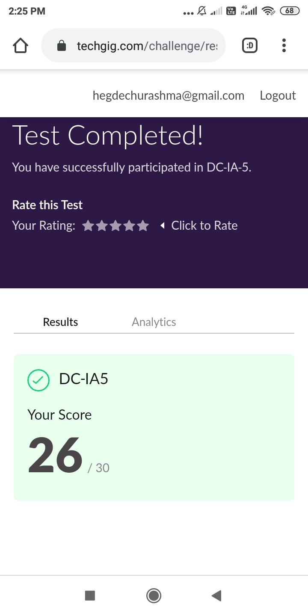

CERTIFICATION COURSE DETAILS: Today I studied about data types and data structures. R's basic data types are character, numeric, integer, complex, and logical. R's basic data structures include the vector, list, matrix, data frame, and factors. R has four main built-in Data Structures: Vector, List, Matrix, and Data Frame.

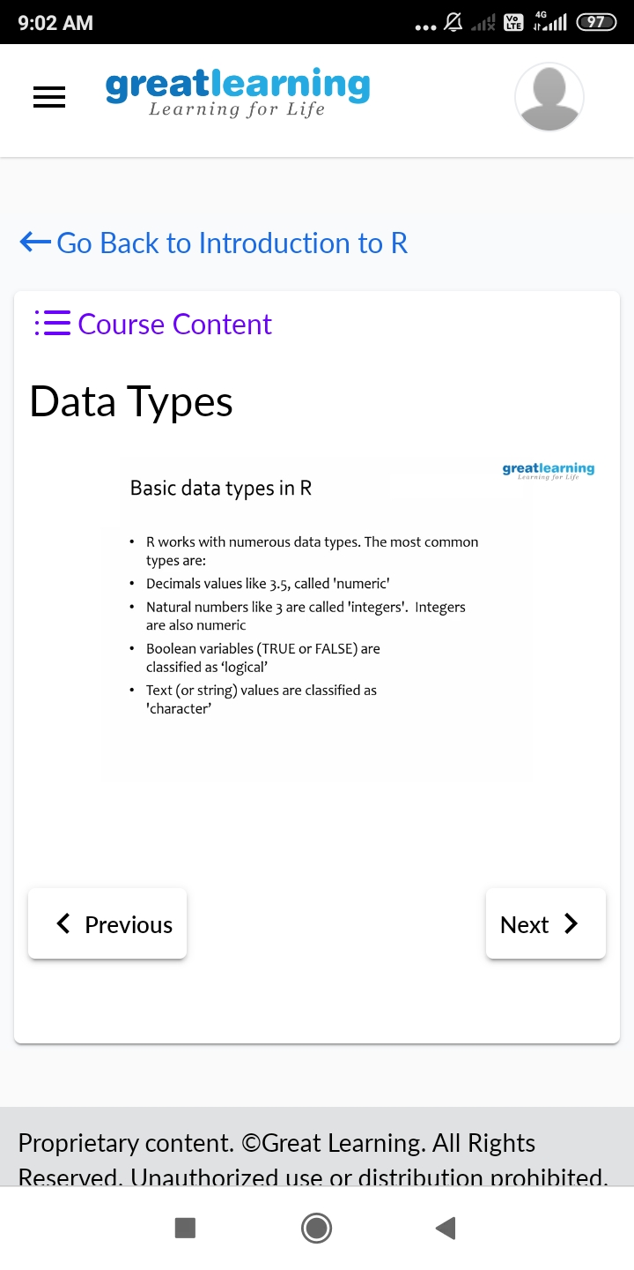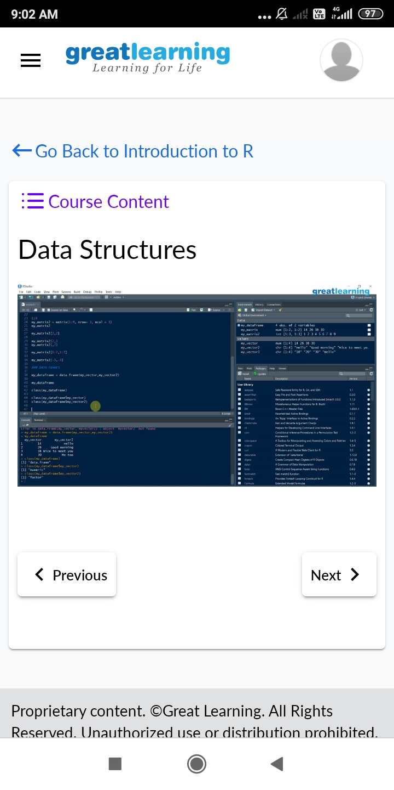

**CODING CHALLENGES DETAILS**:

Problem statement 1: Program that compares counting words in files using an ArrayList and a Map.

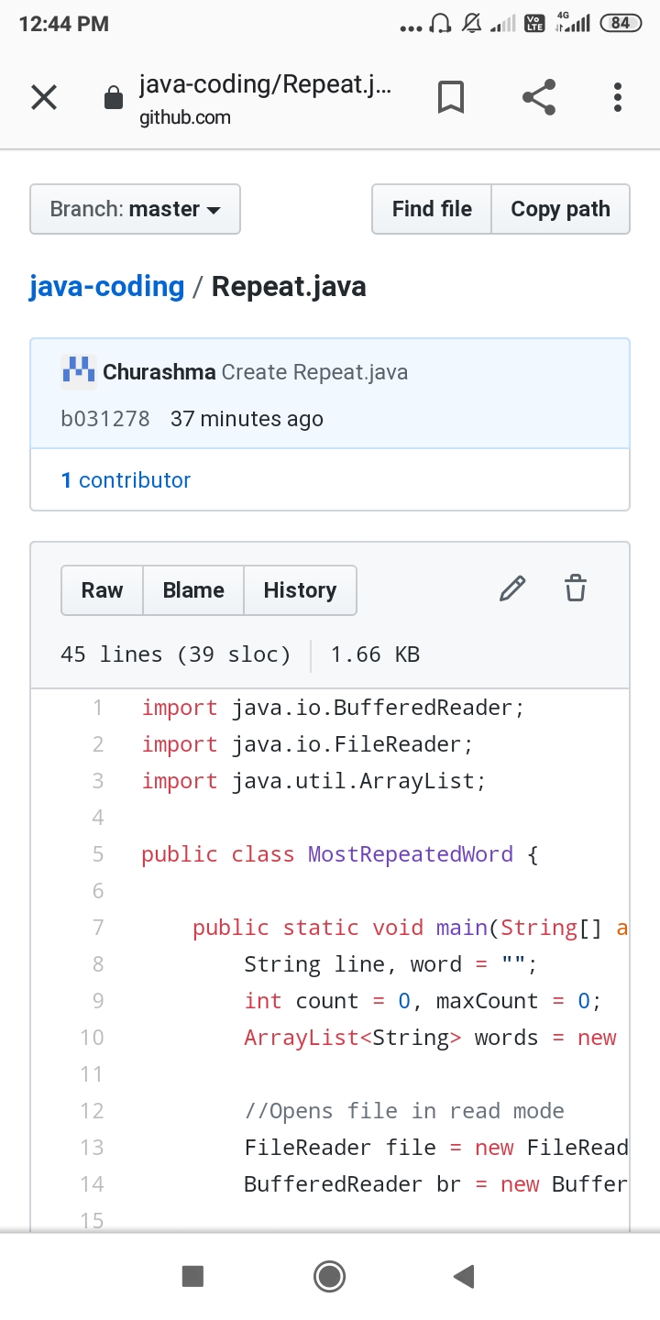

Problem statement 2: Write a C Program to rotate a Matrix by 90 Degree in Clockwise or Anticlockwise Direction. Implement (Both the rotations in single program using switch case statement).

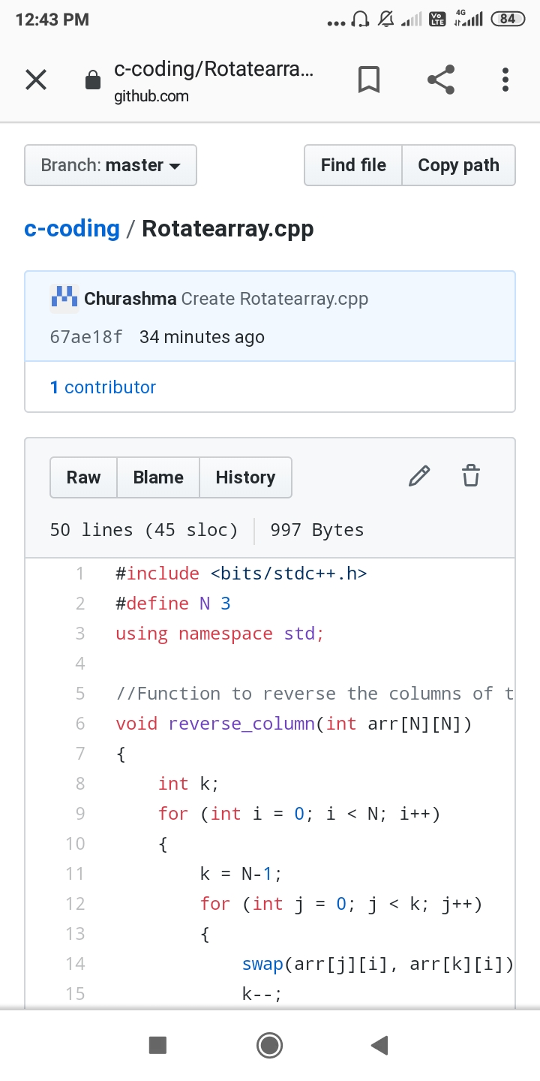

Problem statement 3: Write a Java program to count number of bits to be flipped to convert A to B.

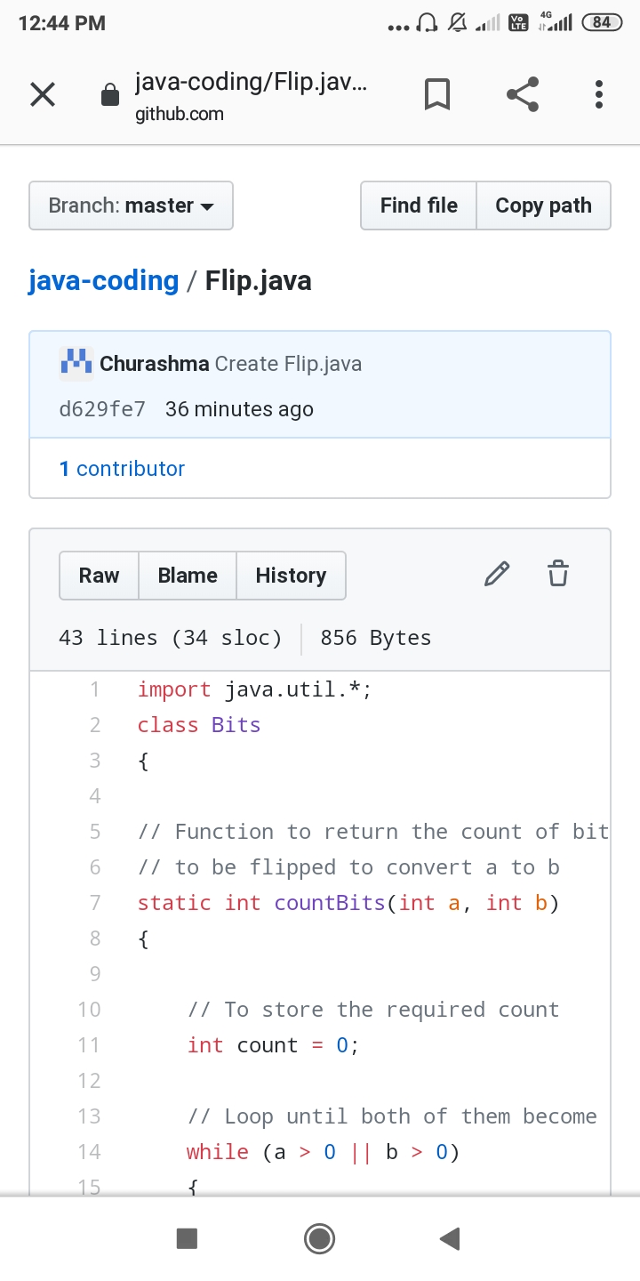

Proble statement 4: Write a C Program to rotate an array by K positions.

